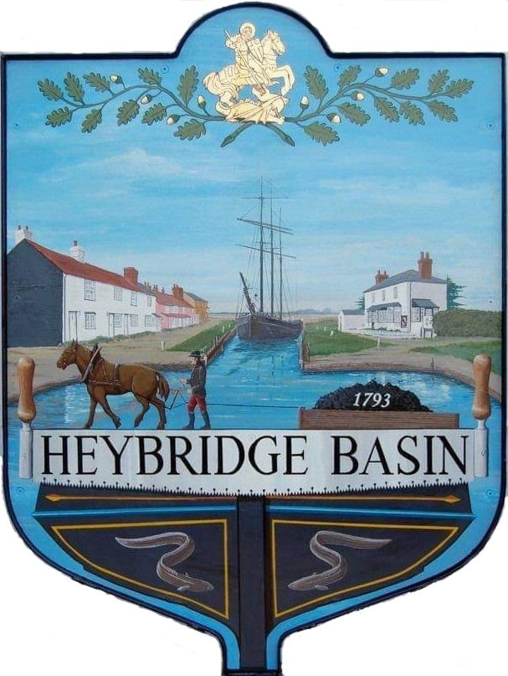

HEYBRIDGE BASIN PARISH COUNCIL

Minutes of the Full Council meeting of Heybridge Basin Parish Council held on Tuesday 20th June 2023 at 6.30pm

Present – Cllrs M. Hodges (Chair), R. Bryson (Vice Chair), J. Sjollema, C. Edmond, M. Hobden and C. Swann.

Also present – G. Lake – Clerk, District Cllrs N. Spenceley and N. Swindle and 2 members of public.

Recording of meetings
Please note, the Council may have recorded any part of this meeting held in open session. Members of the public who attended the meeting and spoke are deemed to have given permission to be included in the recording.

23/24 Chair’s Welcome
The Chair opened the meeting and advised members of the public that the Clerk was recording the meeting.

23/25 Apologies for Absence.
- To receive and accept apologies for absence.
Apologies for Cllr Howat were approved.

23/26 To receive Declarations of Interest in accordance with the Council’s Code of Conduct and with section 106 of the Local Government Finance Act 1992.
Cllr Edmond – Non-Pecuniary – Essex Waterways, Cllr Swann – Non-Pecuniary – Owner of Tea room building, Cllr Hobden – Non-Pecuniary – HBSA, Basin Oars and HB Rivercare.

23/27 To sign as a correct record the minutes of the full council meeting held on 16th May 2023.
The Minutes as previously circulated were agreed as a correct record.

23/28 To receive a report from the District and County Councillors for the area on any matters of interest.
A report from the District Cllrs had been circulated. The chair thanked the District Cllrs as this was the first written report the Parish Council had received from their District members.
There was no report from Cllr Durham.

23/29 Internal Auditor
  - To receive an update from the Clerk and agree any action to be taken.
Cllr Hodges thanked the Clerk for getting the Council successfully through the Audit.
The clerk informed members that the cost of the Internal Audit was £180.00 more than quoted due to the increase income and expenditure, and the complexities of the 3 bank accounts.
It was resolved to pay the additional £180.00 from the DMCP Bank Account.

23/30 Finance.
- To approve
- Payment requests for May/June 2023.
The Payments as previously circulated were approved.
- Receipts for May/June 2023.
The receipts as previously circulated were approved.
- To consider setting up a Direct Debit for the ICO renewal.
It was resolved to set up a Direct Debit for the ICO renewal and receive the £5.00 reduction.
- To receive an up update from the Clerk regarding the Council’s Insurance and Asset Register.
The Clerk informed members that the Asset Register had been amended due to new information regarding ownership of the Street Lights and therefore the annual cost of the Insurance for the 3 years had reduced to £349.49.

23/31 External Audit for 2021-2022
- To receive Section 3 – External Auditor Report and Certificate 2021/22 of the Annual Governance and Accountability Return (AGAR)
The External Auditor Report and Certificate (Section 3) of the AGAR for 2021/22 was received.

23/32 Annual return for the year ending 31st March 2022
- To approve and sign the Annual Governance Statement (Section 1) of the Annual Governance and Accountability Return (AGAR) for 2022/23
The Annual Governance Statement (Section 1) of the AGAR for 2022/23 were approved and signed.
  - To approve and sign the Accounting Statements (Section 2) of the AGAR for 2022/23.
The Accounting Statements (Section 2) of the AGAR for 2022/23 were approved and signed.
  - To note and approve the Internal Audit Report from April Skies for 2022/23.
Recommendations from the report were:
- Councillors are asked to initial or sign payment schedules clearly, so they can be checked by audit at a later date – The Clerk has amended the payment schedules so that members can sign clearly going forward.
- The Council does not currently hold any earmarked reserves – It was resolved to earmark £100k to remove the conifers and resurface the DMCP access road, as well as hold £17k in general reserves.
- The External Audit report for 21/22 had not been reported to a Full Council meeting – This was actioned above.
- Timesheets for the Clerk are checked by the Chair but should also be signed with the payment schedules and invoices – This was noted and as of the Tuesday 20th June 2023 meeting will be actioned.
The Internal Audit Report from April Skies for the 2022/23 financial year as previously circulated was noted and approved. .
  - To approve date of inspection by Electors.
It was resolved that the date of inspection by Electors would be Friday 23rd June 2023 to Thursday 3rd August 2023.

23/33 Training
- To consider registering members onto any relevant training courses.
It was resolved that Cllr Hodges would attend the 2-day Councillor training Course. Clerk to book.

23/34 Public Forum (15 minutes)

No members of public spoke.

23/35 Committees and Working Groups
- To consider creating a committee or Working Group for the following projects:
- Speed Watch
It was resolved to create Speed Watch WG which would consist of Cllrs Hodges, Bryson, Edmond, Hobden and Sjollema, as well as the Clerk and the registered volunteers.
- Neighbourhood Plan/Village Design Statement
It was resolved to advertise in the Newsletter and identify resources and discuss at the next meeting.

23/36 On Street Parking
- To receive an update from the On-Street Parking WG and agree any action to be taken.
An update from the WG was received. It was resolved to proceed with an application to South East Parking Partnership to change some of the parking regulations within the village.

23/37 United Reformed Church
- To discuss the URC and agree any action to be taken.
The report created by Cllr Howat in February was recirculated. It was resolved for the Clerk to send the report to the District Cllrs and to discuss at the next meeting.

23/38 Planning Applications
- To consider any planning applications received after the publication of the agenda and to agree the action to be taken.
There were no planning applications.

23/39 Clerk’s Report
- Land adjacent to St Georges Church – Clerk had chased HM Land Registry for an update on the application and was still awaiting a response.
- MDC – The Clerk was still awaiting updates from MDC regarding the Goal Posts, Pedestrian Sign for St George’s Close and Planning Permission information for the DMCP access road. The District Cllrs were now assisting.
- Parking direction signs – It was resolved for the Clerk to order the 2 Parking Direction signs from SP.
- Noticeboard near Jolly Sailor – It was noted that this needs changing to Heybridge Basin. It was resolved for Cllr Hodges to obtain a quote from Blackwater Printing.

23/40 Newsletter
- To consider items to be included in the next Parish Council Newsletter and agree any action to be taken.
- Speed Watch Group/ SEPP Application
- Coronation Plaque
- New elected members of the PC
- MDC Paddle Sports
- MDC Future Transport Strategy
- Defibrillator Training Group
- Village Design Statement (VDS)

23/41 Correspondence
- To note correspondence received and any actions to be taken.
Correspondence was noted and responses were agreed.

23/42 Local Issues
- To note any items of inclusion on the agenda for the next meeting of the Parish Council.
There were none.

There being no further business the meeting closed at 08:16pm
Provisional Date of the next Council Meeting Tuesday 18th July 2023.

Clerk Contact details: clerk@heybridgebasinpc.org.uk
Website: www.heybridgebasin-pc.gov.uk

